**Measurement 2: Maxillary Prognathism**

Introduction: In this section the degree of maxillary prognathism will be measured using a protractor. The teeth and the bones around the mouth provide a great deal of information about both a species’ diet and how it eats. This exercise concerns the maxilla, a two-bone fusion that forms the upper jaw. Take a moment to identify the maxilla and where the zygomatic process (cheekbone) meets the cranium. Facial prognathism is the extent to which the face and jaws protrude forward when looking at the skull from the side. Prognathic skulls are marked by larger mandibles, and consequentially larger teeth.

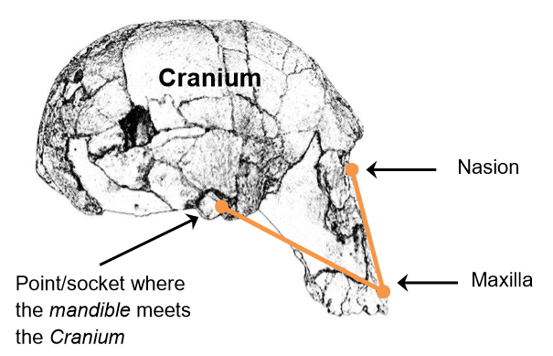**Guiding Question: How do the upper jaws/mouths of hominins compare?**

**Measure**: As shown above, hold the skull sideways, align the upper end of the extension block with the nasion, the nasal depression between the orbital sockets, and the lower end with tip of the maxilla, right before the teeth emerge. The extension should be situated below the brow ridge and above the teeth.

Then, identify the socket point of the mandible and the cranium located right below the meeting point of the zygomatic process and the cranium. Rotate the protractor's arm such that it hovers over this point - the resulting angle (vertex) is the maxillary angle. Be sure to record the acute angle for each skull.

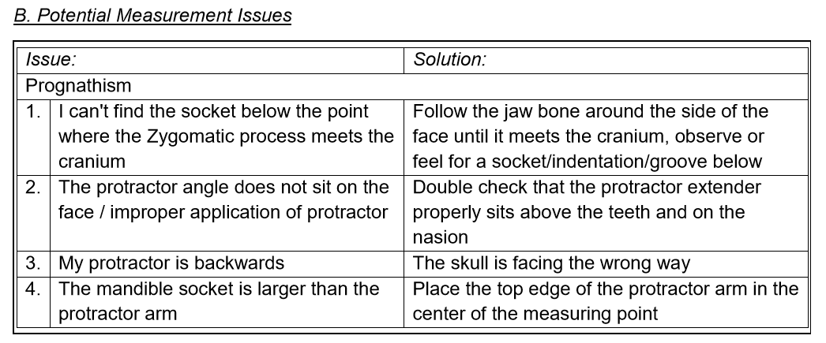

C. Analyze: Examine the maxillary prognathism you calculated.

Q. Which species had the largest maxillary prognathism? A. Austalopithecus aethiopicus had the most acute angle implying it protruded the most. The Australopiths are defined by their smaller brains but larger faces, and it should be noted that the genus has more gracile (smaller) species, such as A. afarensis and A. africanus, and more robust (larger) species, such as A. boisei and A. aethiopicus. This division is argued as warranting a new genus name (Paranthropus), but the jury is still out.

Q. Which species had the smallest maxillary prognathism? A. Homo sapiens had the largest angle implying the flattest face. Although A. Boisei and Homo sapiens are roughly the same physical size, it is very clear that humans have a much smaller jaw and a larger brain.